Mane Attraction Dance Team
2024-2025 Auditions

Mandatory Parent Meeting

Thursday, March 28 at 6 pm in the dance room, 2-012

Audition Clinics:

Monday April 1 4:30-7 (Optional)
Tuesday April 2 4:30-7
Wednesday April 3 3:30-6

Final Audition:

Thursday April 4 4 -7

Final Auditions will take place beginning with current
OHS students followed by 8th grade students. 8th graders do NOT need to leave school early but should get to OHS as soon as possible. End time is approximate depending on number of dancers auditioning. There may be same-day callbacks so we recommend staying until everyone is dismissed.

Attire: Please wear ALL BLACK to clinic and audition! Leggings, tights and shorts, leotards, fitted t-shirts, and tank tops are all acceptable clothing. Any dance shoe is permitted to audition.

Try-out Fee: Please bring $20 cash or check (to Oviedo High School) along with ALL signed forms from the parent meeting with you to Tuesday’s clinic. Must bring a copy of an up-to-date physical.
VISIT OUR WEBSITE WWW.MANEATTRACTIONDANCE.COM FOR SKILLS LIST.
Please contact Coach Jennings with any questions or conflicts. futatoaz@scps.k12.fl.us

OHS DANCE TEAM AUDITIONS 24-25

SKILLS EVALUATION

Proficiency in the following skills is required for Mane Attraction and recommended for Lionettes

Including but not limited to:
Splits
Battement/High Kicks
Toe Touch
Kip Up
Headspring
Grande Jete/Saut de Chat leaps
Seconde/Center Leap
Pirouettes
Turns in Seconde
Skill of Choice (optional)

DANCE ROUTINE EVALUATION
Memory
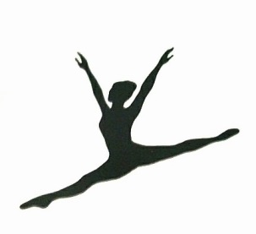
Showmanship
Strength of Movement
Pom Technique
Jazz Technique
Hip Hop Technique

